Leveraging Agentic AI Middleware for Intelligent Interaction and Modernization of Legacy Enterprise Applications

M.Z.M.Ayyash
Department of Software Engineering Sri Lanka Institue of Information Technology
Malabe, Sri Lanka
it22355850@my.sliit.lk
D.N.RAJAPAKSHA
Department of Software Engineering Sri Lanka Institue of Information Technology
Malabe, Sri Lanka
It22311436@my.sliit.lk
M.A.M.Mufthi
Department of Software Engineering Sri Lanka Institue of Information Technology
Malabe, Sri Lanka
It22355478@my.sliit.lk
Mr. Vishan Jayasinghearachchi
Department of Software Engineering Sri Lanka Institue of Information Technology
Malabe, Sri Lanka
vishan.j@sliit.lk
S.M.A.C.M.Rashad
Department of Software Engineering Sri Lanka Institue of Information Technology
Malabe, Sri Lanka
It22331472@my.sliit.lk
Dr. Dharshana Kasthurirathna
Department of Software Engineering Sri Lanka Institue of Information Technology
Malabe, Sri Lanka
dharshana.k@sliit.lk

Abstract—This electronic document is a “live” template and already defines the components of your paper [title, text, heads, etc.] in its style sheet. *CRITICAL: Do Not Use Symbols, Special Characters, Footnotes, or Math in Paper Title or Abstract. (Abstract)
Keywords—component, formatting, style, styling, insert (key words)

Introduction
Legacy enterprise software remains deeply embedded across healthcare, finance, government, and manufacturing sectors worldwide. A 2023 industry survey estimated that organizations collectively spend over $300 billion annually maintaining legacy systems, with most of that expenditure directed at preventing failures rather than enabling innovation [1]. Despite this cost, full system replacement remains out of reach for most organizations — developers rarely hand over source code to clients, making recreation from scratch both technically difficult and financially prohibitive. The systems, however outdated their interfaces, continue to perform their core functions correctly.
Legacy desktop applications are typically tied to specific operating systems and hardware, blocking remote access and mobile use. In healthcare in particular, staff must physically access dedicated machines to perform registration, scheduling, or billing tasks — creating bottlenecks that slow care delivery and increase error rates.
Robotic Process Automation (RPA) offers a different path. RPA bots interact with applications through the same graphical interface a human would use, requiring no access to source code or internal APIs. However, traditional RPA is fragile: hard-coded sequences break when screen layouts change, and there is no capacity to handle variable user input intelligently.
This paper addresses that fragility by introducing an AI-driven orchestration layer above the RPA execution stack. Users interact through a modern interface generated from the legacy system's UI. Inputs are passed to a planning module that identifies the required bots and sequence, which an orchestration module then executes directly within the legacy application — with zero modification to the underlying system.
The specific contributions of this work are as follows:

- A hybrid AI-rule execution planning architecture combining LLM flexibility with rule-base determinism to generate reliable GUI action plans.
- A lightweight RPA bot framework in AutoHotkey, built for Win32-era applications incompatible with commercial RPA platforms.
- A stateful orchestration engine with step-by-step pre-condition verification and graceful failure handling.
- An empirical evaluation against a Visual Basic 6 Hospital Management System, demonstrating measurable improvements without any modification to the legacy application.

Related Work

Legacy System Modernization
Bennett [1] established the foundational challenge: legacy systems become harder to replace precisely because they succeed—embedding deeply into workflows over time. Kazman et al. [7] developed architecture reconstruction techniques that identify hidden dependencies without full re-engineering, while Pérez-Castillo et al. [8] demonstrated screen-scraping as a viable non-intrusive extension mechanism for mainframe systems in regulated environments. Market analyses show that modernization projects average 16 months, cost $1.5M, and fail or are abandoned 80% of the time [4]—making non-intrusive alternatives commercially compelling.

Robotic Process Automation
Lacity and Willcocks [5] confirmed RPA's value for rule-based GUI tasks while identifying selector fragility as the dominant long-term challenge. Ribeiro et al. [9] reviewed 52 studies and found that AI-enhanced RPA significantly improves UI-drift resilience but that existing implementations still lack higher-level coordination layers. El-Gharib et al. [10] showed process mining can identify optimal automation points, improving RPA deployment efficiency. Oberhauser and Pogolski [6] proposed partially self-healing RPA for minor interface changes, but without multi-agent coordination or API exposure capabilities.

AI-Driven GUI Understanding
Beltramelli's pix2code [11] demonstrated 77% accuracy generating UI code from screenshots using CNN-LSTM architectures, establishing the feasibility of semantic GUI analysis without framework access. The RICO dataset [12] provided large-scale UI training data. OmniParser [13] advanced the state of the art by parsing screenshots into structured element trees for reliable action grounding. UI-TARS [14] demonstrated autonomous GUI agents operating through native interfaces via visual understanding alone—the closest prior work to the proposed RPA connector, though operating as a standalone agent without coordination or API exposure.

Multi-Agent Coordination
Smith's Contract Net Protocol [15] established capability-based decentralized task allocation. Nii's Blackboard Architecture [16] introduced shared-memory opportunistic coordination, both adapted in the proposed Orchestrator Agent. BDI models [17], [18] formalized goal-directed planning with dynamic revision—directly informing SOACRS's pre/post-condition planning. Li et al. [19] introduced contextual bandits for online adaptive agent selection, balancing exploration and exploitation based on real-time context features. AgentOrchestra [20] and DynTaskMAS [21] demonstrated hierarchical and asynchronous orchestration for complex multi-agent environments, validating the DAG-based execution model.

Reliability and Observability
Garcia-Molina and Salem's Sagas pattern [22] addresses long-running transaction recovery through atomic sub-transactions with compensatory actions—directly applied to SOACRS plan construction. Sigelman et al.'s Dapper [23] provides the distributed tracing foundation ensuring auditability of all delegation decisions and execution outcomes in the proposed observability stack.

Research Gap
No existing system combines automated UI generation from screenshots, BDI-inspired adaptive planning with contextual bandit delegation, DAG-based orchestration with compensation, CNN-driven adaptive RPA execution with digital-twin validation, and REST/GraphQL API exposure—all without legacy source-code access. LAMA directly addresses this compound gap.

System Architecture And Methodology
This framework modernizes legacy desktop applications without modifying their code. It begins with a “Scan Legacy System” feature that captures a screenshot of the active interface. A large language model (LLM), such as Meta LLaMA, processes this image to extract structured information and produce a JSON representation.
The JSON is used to generate a modern, web-based UI using React, Vite, and CSS, allowing users to interact with the legacy system through an accessible interface. All inputs are stored in a centralized database (e.g., MongoDB) and sent via WebSocket to an orchestrator, which plans and sequences tasks across RPA bots.
The RPA bots execute actions at the GUI level, performing data entry, retrieval, and updates on the legacy system while it runs in the background. This approach enables remote, platform-independent access to legacy systems, even on outdated environments like Windows XP, without altering the original application.
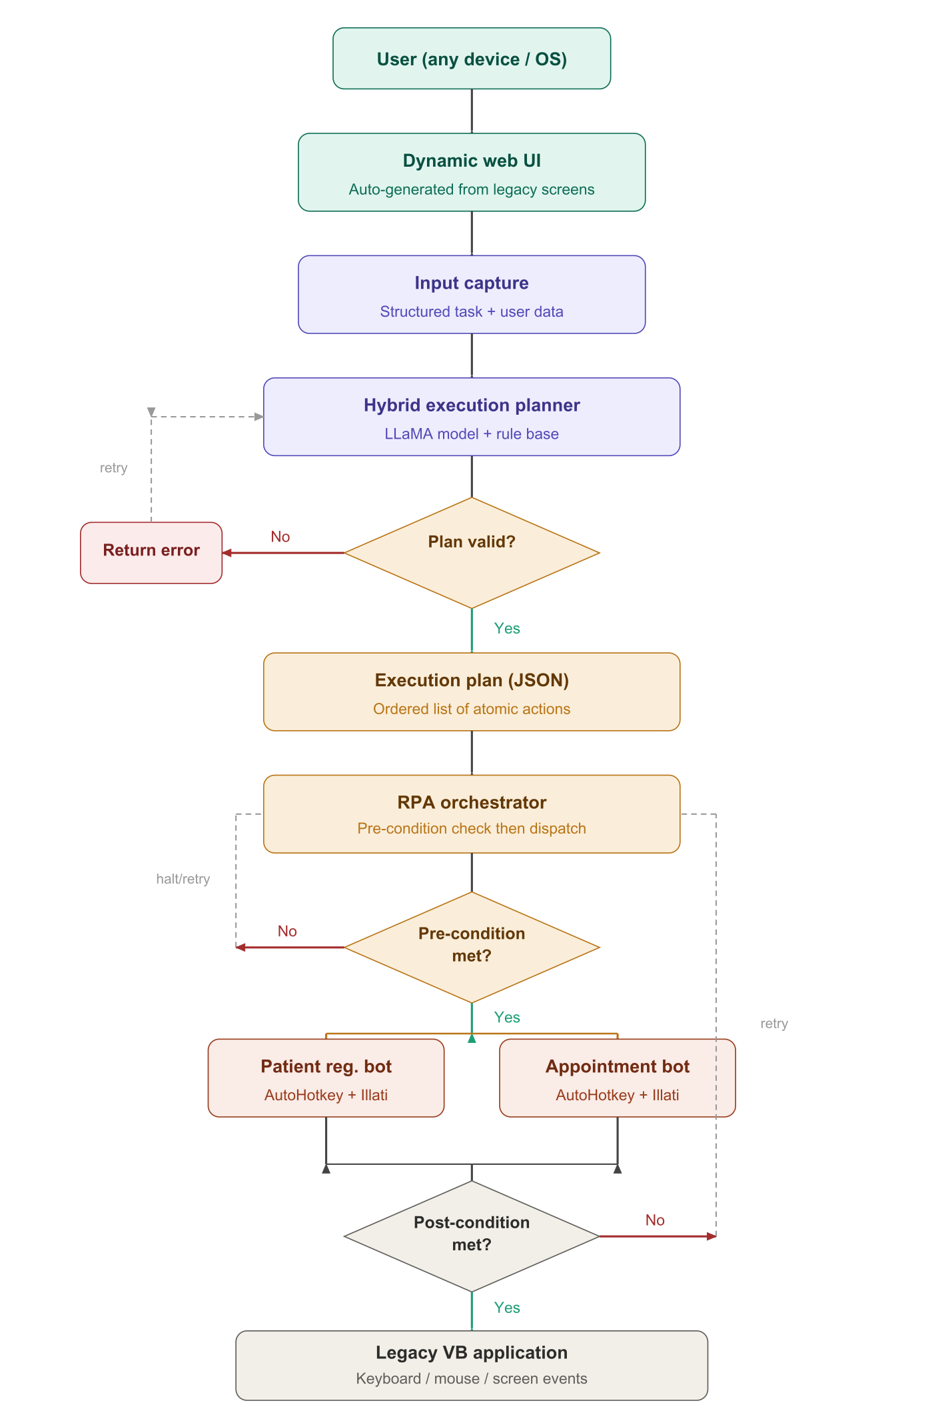

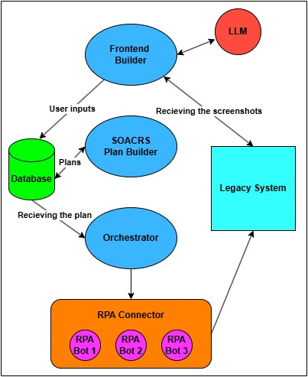
Dynamic Modern UI Generation from Legacy Interfaces
The Frontend Builder eliminates the accessibility barrier of legacy systems by auto-generating a full modern web interface from screenshots, enabling remote access from any device without requiring local OS configuration or legacy software installation.
Each target legacy screen is captured as a PNG via PyAutoGUI. The image is submitted to an LLM (Meta LLaMA 3.1 70B or GPT-4V) with a structured prompt requesting JSON extraction of five element categories: form fields (with labels, data types, and validation constraints), action buttons, navigation controls, display elements, and workflow relationships between screens. The LLM infers data types from field labels (e.g., "Date of Birth" → date picker) and validation rules from context (e.g., "Patient ID" → numeric, required). Low-confidence extractions are flagged for human review before deployment.
The validated JSON schema is consumed by a code-generation pipeline that maps each element to its React equivalent—controlled inputs with HTML5 types, Zod-validated form schemas, React Router navigation, and sortable data tables. Styling uses Tailwind CSS following WCAG 2.1 AA accessibility guidelines. Every user action triggers a structured JSON event object (action type, field values, session token, trace UUID) transmitted via Secure

WebSocket to SOACRS. Real-time status updates are pushed back to the interface as the Orchestrator executes the corresponding RPA workflow.

Soacrs – The Plan Builder
SOACRS (Self-Optimizing Agent Coordination & Response Service) is a lightweight Node.js microservice designed to act as the decision-making backbone of a larger agentic AI middleware system. Rather than executing tasks itself, it sits between a natural language translator and an orchestrator, taking in structured task descriptions and producing detailed routing plans that tell downstream components which tool to invoke, in what sequence, and how to recover from failure. The service is built around a clean separation of concerns pure domain models, framework agnostic application logic, and database backed infrastructure adapters, making it both testable and easy to extend without breaking existing contracts.

At its core, the routing decision is driven by a scoring engine that evaluates candidate tools across four dimensions: whether they support the requested capability, how reliably they have performed in the past, how users have rated their outcomes, and how costly they are to run. These factors are combined into a single weighted score, with the highest ranked tool selected as the primary and the next-best reserved as a fallback. The resulting plan is structured as a small state machine, with explicit transitions defined for success, failure, and timeout scenarios, giving the orchestrator a clear path to follow regardless of what happens during execution.

Orchestration of Multi-Agent Automation Systems

RPA Bot Interaction with Legacy Systems

Experimental Evaluation

Setup and Target System
The evaluation target is a Visual Basic 6 hospital patient-management application (HIS-VB6) running inside Oracle VirtualBox 7.0 with Windows XP SP3, 512 MB RAM, and 1024×768 resolution. The VM host is a Windows 11 workstation. Three workflows were evaluated 50 times each: Patient List Retrieval (navigate, OCR, return records), Add New Patient (navigate, fill 7 fields, submit, verify), and Remove Patient (navigate, open dialog, inject ID, confirm).

Metrics
Four primary metrics were measured: Task Success Rate (fraction of fully successful executions), Average Execution Time (API receipt to result return), OCR Field-Level Accuracy (exact-match rate for extracted patient list fields against ground truth), and Workflow Recovery Rate (fraction of initially failing executions ultimately completed via retry or fallback).

Results and Analysis
Table I presents results across all workflow categories. Add New Patient had the longest execution time (11.8 s) due to seven sequential fields and mandatory post-insertion verification. Patient List Retrieval had the lowest success rate (97.3%) from occasional OCR column misalignment for long patient names. Remove Patient achieved the highest success rate (98.1%) with the fewest interaction steps.

Of 27 total initial failures across 150 trials, 24 recovered automatically through retry and fallback strategies; only 3 required human intervention (VM display rendering timeouts during screenshot capture). No executions required full Sagas compensation, confirming that retry and fallback strategies handled all observed failure modes. The contextual bandit model demonstrated observable learning: by trial 30, SOACRS had learned to prefer the coordinate-based agent for the Date of Birth field specifically, because the vision detector systematically misidentified the date-
Workflow | Avg. Time (s) | Success | OCR Accuracy | Recovery
Patient List Retrieval | 4.2 s | 97.3% | 94.1% | 100%
Add New Patient | 11.8 s | 95.6% | N/A | 96.4%
Remove Patient | 7.4 s | 98.1% | N/A | 100%
Overall / Average | 7.8 s | 97.0% | 94.1% | 98.8%
Table 1-Evaluation Results (50 Trials Per Workflow)

Conclusion
This paper presented LAMA, a four-component agentic AI middleware framework that modernizes legacy enterprise applications without modifying their source code. By combining LLM-powered interface generation (Frontend Builder), BDI-inspired adaptive planning with contextual bandit delegation (SOACRS), DAG-based multi-agent orchestration with Sagas-pattern compensation (Orchestrator), and CNN-driven adaptive RPA with digital-twin validation and API exposure (RPA Connector), LAMA creates a complete, intelligent bridge between inaccessible GUI-only legacy systems and modern digital workflows.
Evaluated on a Visual Basic 6 hospital patient-management system inside a Windows XP virtual machine—representing a realistic worst-case modernization scenario—the framework achieved 97.0% mean task success, 7.8 s average execution time, 94.1% OCR field accuracy, and 98.8% workflow recovery across 150 trials, with zero legacy code modification. The self-optimizing delegation mechanism demonstrated autonomous adaptation to systematic execution errors, validating the framework's practical resilience.
LAMA offers healthcare, finance, and government organizations a practical, low-risk modernization pathway that preserves operational continuity while immediately delivering the integration, automation, and accessibility benefits of modern platforms. The framework and evaluation datasets will be released as open-source to support reproducibility and further research in agentic legacy system modernization.

References
[1] Gartner Inc., "Legacy Application Modernization Market Report," Gartner Research, Stamford, CT, USA, 2023.
[2] R. C. Seacord, D. Plakosh, and G. A. Lewis, Modernizing Legacy Systems: Software Technologies, Engineering Process and Business Practices. Boston, MA, USA: Addison-Wesley, 2003.
[3] M. Bisbal, D. Lawless, B. Wu, and J. Grimson, "Legacy information systems: Issues and directions," IEEE Software, vol. 16, no. 5, pp. 103–111, Sep. 1999.
[4] W. M. P. van der Aalst, M. Bichler, and A. Heinzl, "Robotic process automation," Business and Information Systems Engineering, vol. 60, no. 4, pp. 269–272, Aug. 2018.
[5] J. G. Enriquez, A. Jimenez-Ramirez, F. J. Dominguez-Mayo, and J. A. Garcia-Garcia, "Robotic process automation: A scientific and industrial systematic mapping study," IEEE Access, vol. 8, pp. 39 113–39 129, 2020.
[6] A. Jimenez-Ramirez, I. Ramos, and J. Seco, "Automatic generation of RPA scripts from user interface recordings," in Proc. IEEE Int. Conf. on Services Computing (SCC), Milan, Italy, 2019, pp. 152–159.
[7] J. Wei et al., "Chain-of-thought prompting elicits reasoning in large language models," in Advances in Neural Information Processing Systems (NeurIPS), vol. 35, New Orleans, LA, USA, 2022, pp. 24 824–24 837.
[8] J. S. Park et al., "Generative agents: Interactive simulacra of human behavior," in Proc. 36th ACM Symp. on User Interface Software and Technology (UIST), San Francisco, CA, USA, 2023, pp. 1–22.
[9] AutoHotkey Foundation LLC, "AutoHotkey v1.1 Documentation," 2023. [Online]. Available: https://www.autohotkey.com/docs/
[10] M. Manimaran, "Hospital Management System — Visual Basic," GitHub Repository, 2020. [Online]. Available: https://github.com/manimaran96/HospitalManagementSystemVisualBasic

